[CLUB NAME] is proud to announce it will be hosting a Golf BioBlitz
on [DATE(S)], joining a growing movement of golf clubs worldwide championing biodiversity and sustainability within the sport.
The event will raise awareness about the importance of preserving the environment and natural resources for future generations, while shining a light on the rich natural habitats that golf courses can support
The event has been made possible thanks to [NAME OF SPONSOR/DONOR/PARTNER], whose support has helped bring this community initiative to life.
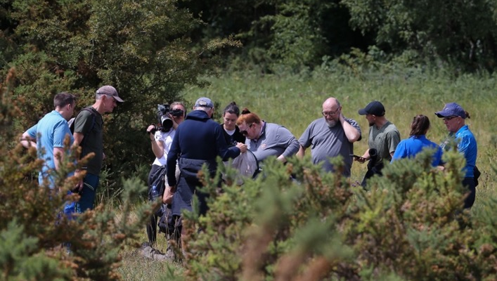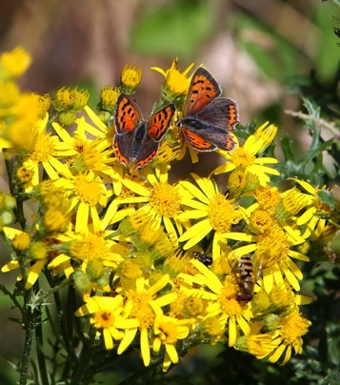
What is BioBlitz?
‘Bio’ means ‘life’ and ‘Blitz’ means ‘to do something quickly and intensively’. Together, they make ‘BioBlitz’, an engaging and collaborative race to discover as many species of plants, animals and fungi as possible within a set location in just one day.
The goal is to create a snapshot of the rich biodiversity present on the course, helping clubs better understand and protect the wildlife they support.
About the event
[CLUB NAME] has a [DESCRIBE KEY HABITATS – e.g. "diverse range of woodland, grassland and wetland habitats"].
Local school children, nature volunteers, conservation groups and community members will come together to record and better understand the range of wildlife supported by the course.
The event will be led by wildlife experts including [NAME(S) AND ROLE(S) OF LEAD ECOLOGIST(S)/EXPERTS] and [CLUB REPRESENTATIVE NAME AND ROLE], who are coordinating the day’s activities.
Over the course of the BioBlitz, there will be organised walks and activities to look for [LIST FOCUS SPECIES/GROUPS – e.g. "bats, birds, butterflies, hedgehogs, moths and wildflowers"].
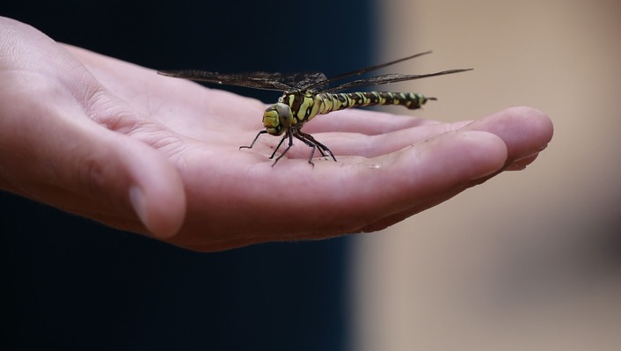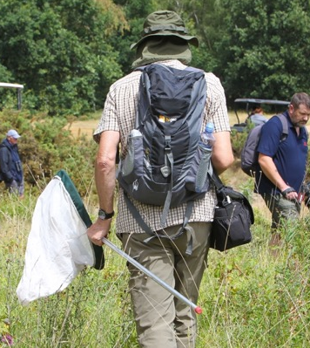
Why it matters
With nature continuing to decline and almost one in six species threatened with extinction in the UK (State of Nature, 2023), events like this are a vital opportunity to monitor the wildlife on our doorstep and take action to protect it
[“Quote from Ecologist or Conservation Expert here. Quote from Ecologist or Conservation Expert here. Quote from Ecologist or Conservation Expert here. Quote from Ecologist or Conservation Expert here. Quote from Ecologist or Conservation Expert here.”]
[Name, Title, Organisation]
Golf courses can serve as incredible sanctuaries for wildlife. Establishing a biodiversity baseline helps clubs protect nature and tailor our management to help endangered species flourish.

[“Quote from Club Representative here. Quote from Club Representative here. Quote from Club Representative here. Quote from Club Representative here. Quote from Club Representative here. Quote from Club Representative here. Quote from Club Representative here. Quote from Club Representative here.”]
[Name, Title, Club name]
[“Optional quote from partner organisation, sponsor or local authority here. Optional quote from partner organisation, sponsor or local authority here. Optional quote from partner organisation, sponsor or local authority here. Optional quote from partner organisation, sponsor or local authority here. Optional quote from partner organisation, sponsor or local authority here.”]
[Name, Title, Organisation]
Get involved
We’d love for the local community to come along and be part of this special event. Optional: Admission is free / Tickets are available.
Find out more and book your place at [insert website / booking link]

For press enquiries, please contact [Name] at [Email address / Phone number].

[CLUB NAME] | [ADDRESS] | [WEBSITE] | [SOCIAL MEDIA HANDLES]

